A000-Eur-Czech Republic-Dolní Věstonice-Anthropomorph-Female-29,000-22,000 BP-Gravettian



Fig. 1. Czech Republic-Dolní Věstonice-Anthropomorph-Female-29,000-22,000 BP-Gravettian

Formal Label: Czech Republic-Dolní Věstonice-Anthropomorph-Female-29,000-22,000 BP-Gravettian

Accession Number: A000

**Display Description:** Stylized anthropomorphic female from a site near village of Dolni Vestonice, at the base of Děvín Mountain 549 m (1,801 ft) asl., 29,000-22,000 BP. Many artifacts were excavated here including carved images of men, women, animals, and personal ornaments.

**LC Classification:** GN772.2.P4

**Date or Time Horizon:** 29,000-22,000 BP

**Geographical Area:** Moravia in the Czech Republic, on the hill of Pollau.

**Map, GPS 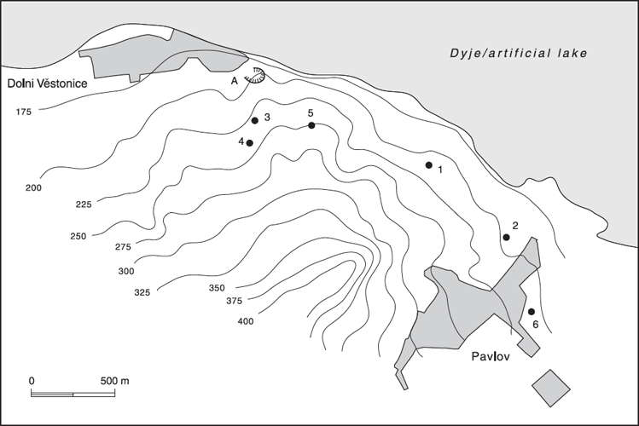Coordinates:** 48.88826 16.64364.

Fig. 2. Relief map showing Upper Paleolithic sites along the northeast side of the Pollau Hill. Dark line is the Dyje River. After Verpoorte (2000). Key: 1. Dolní Věstonice I; 2. Pavlov I; 3. Dolní Věstonice II; 4. Dolní Věstonice II-A; 5. Dolní Věstonice III; 6. Pavlov II.

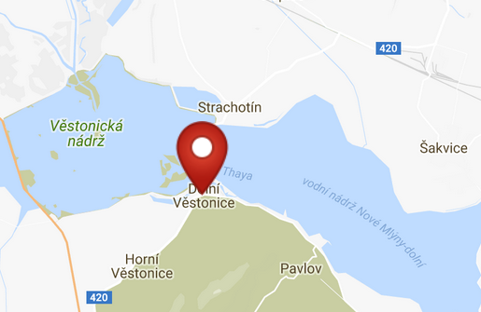 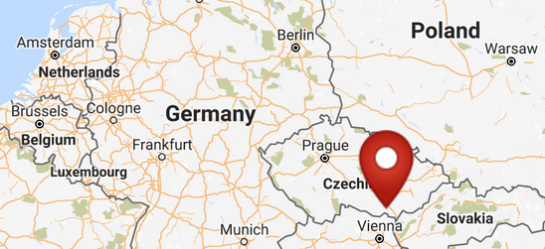

Fig. 3. Map of Dolni Vestonici. Fig. 4. Location of Dolni Vestonici in Europe.

Fig. 5. Map of Dolni Vestonici within Europe. After <http://latitude.to/img/latitude-logo.svg>

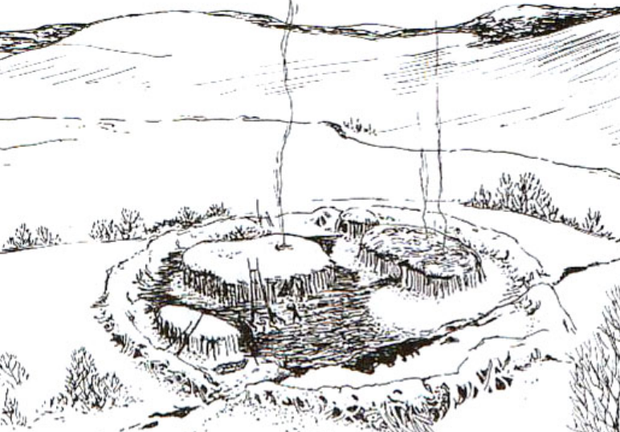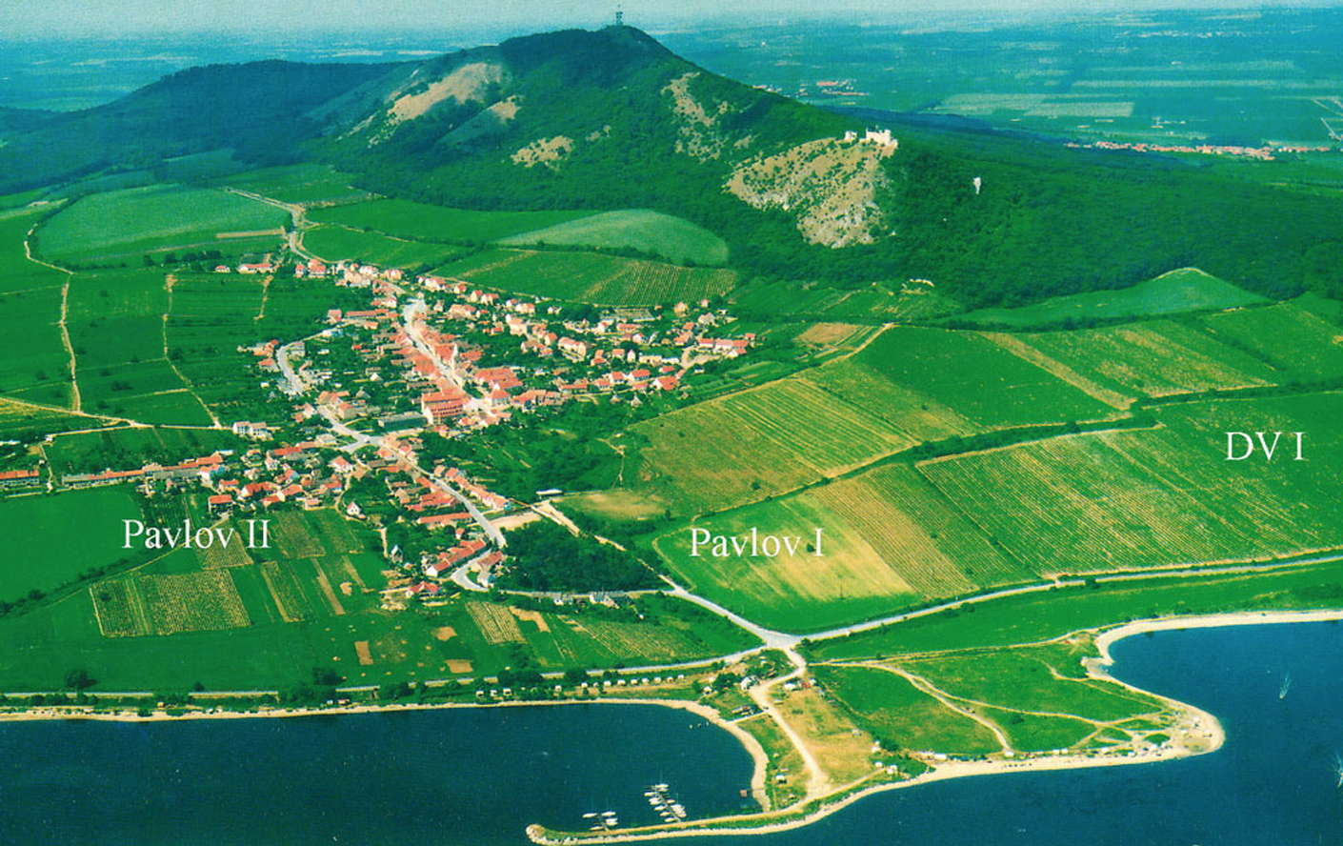

Fig. 6. View of Dolní Věstonice, Moravia, Czech Republic, 29,000 BP, after <http://humanpast.net/images/dolni.JPG>.

Fig. 7. Aerial view of Dolní Věstonice, Moravia, Czech Republic, 2004, after Svoboda (2007)

**Cultural Affiliation:** Gravettian period

Medium: bone.

Dimensions: Height (left) 8.3 cm and (right) 8.6 cm.

Weight: n/a

Condition: museum replica, Top Geo, Sattledorf, Germany

Provenance: Dolní Věstonice, Mikulov, Moravia; Moravian Museum, Brno, Czech Republic

**Discussion:**

This abstract rendition of an anthropomorphic female figure is unique among the Gravettian female figurines, emphasizing the wide pelvic girdle for safe child-birth.

**References:**

Czech Republic, Institute of Archaeology. 2000. [*The people of the Pavlovian: skeletal catalogue and osteometrics of the Gravettian fossil hominids from Dolní Věstonice and Pavlov*](https://franklin.library.upenn.edu/catalog/FRANKLIN_9930226023503681). Dolnověstonické studie; sv. 5. Brno: Academy of Sciences of the Czech Republic, Institute of Archaeology; Dolní Věstonice: Department of Paleolithic and Paleontology.

Klima, Bohuslav. 1995. [*Dolní Vêstonice II : Ein Mammutjägerrastplatz und seine Bestattungen*](http://www.worldcat.org/title/dolni-vestonice-ii-ein-mammutjagerrastplatz-und-seine-bestattungen/oclc/644597596&referer=brief_results)*.* Liège : Université de Liège.

Klima, Bohuslav. 1969. [*Die grosse Anhäufung von Mammutknochen in Dolni Vestonice*](http://www.worldcat.org/title/grosse-anhaufung-von-mammutknochen-in-dolni-vestonice/oclc/644864735&referer=brief_results)*.* Praha: Nakladatelství akademie ved.

Oliva, Martin. 2014. [*Dolní Vestonice I (1922-1942*): Hans Freising, Karel Absolon, Assien Bohmers](http://www.worldcat.org/title/dolni-vestonice-i-1922-1942-hans-freising-karel-absolon-assien-bohmers/oclc/908053144&referer=brief_results).  Brno: Moravské Zemské Muzeum.

Trinkaus, Erik and Jirí Svoboda. 2006. [*Early modern human evolution in Central Europe: the people of Dolní Vestonice and Pavlov*](http://www.worldcat.org/title/early-modern-human-evolution-in-central-europe-the-people-of-dolni-vestonice-and-pavlov/oclc/782889119&referer=brief_results)*.* New York: Oxford University Press.